CENWP-OD-B 08 July 2022

MEMORANDUM FOR THE RECORD

SUBJECT: 22BON033 MFR AFF Sockeye and Smolt Mort

On 07 July, Columbia River Inter-Tribal Fish Commission (CRITFC) Biologists notified Bonneville Project Biologists of one adult sockeye mortality and a salmon smolt mortality found on the Valve 15 trash rack in the Adult Fish Facility (AFF). The fish mortalities were scanned for PIT tags, inspected, and returned to the river.

Adult sockeye mortality:
- Species – Sockeye (Oncorhynchus nerka)
- Origin – NA
- Length – approximately 51 cm
- Marks and tags – No tag, unable to determine adipose fin presence due to state of decay
- Marks and Injuries found on carcass – NA, very decayed
- Cause and Time of Death – Unknown time, discovered on 07 July
- Future and Preventative Measures – None
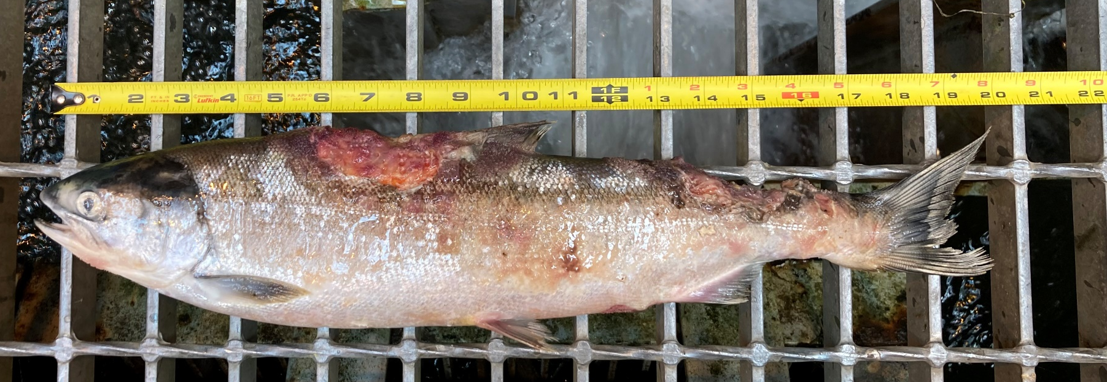

Smolt mortality:
- Species –Oncorhynchus smolt
- Origin – NA
- Length – approximately 25 cm
- Marks and tags – No tag, clipped adipose
- Marks and Injuries found on carcass – NA
- Cause and Time of Death – Unknown time, discovered on 07 July
- Future and Preventative Measures – None
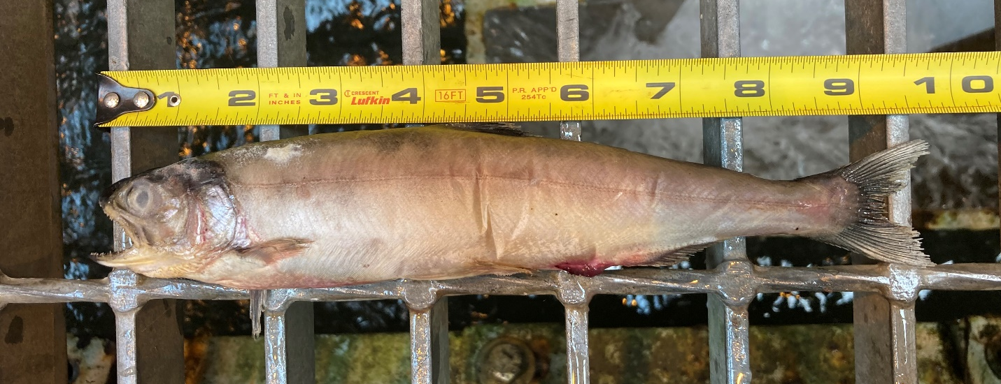
Sincerely,

Bonneville Project Fisheries

